[Type the abstract of the document here. The abstract is typically a short summary of the contents of the document. Type the abstract of the document here. The abstract is typically a short summary of the contents of the document.]

Jordan

**2018**

**Functional Document**

**Functional Description**

Components created :

1. Social network sign-in, session sign-in and out.
2. Admin dashboard page, user dashboard page.
3. Separation of concern for User header component and admin component.
4. Administration table of managing users.

**Social Sign-in**

Social network sign-in (The ability to log in with google, facebook, twitter etc.)

And sign out of our website’s session.



**Admin dashboard**

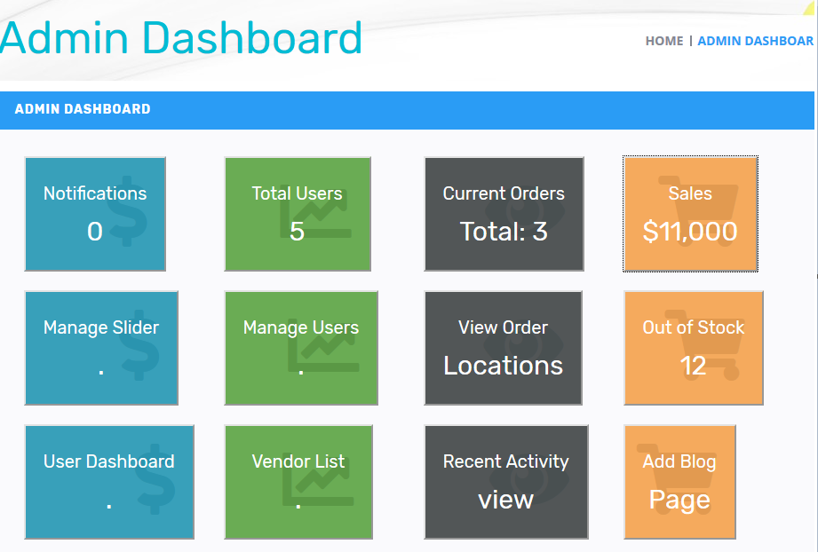

The admin has a list of actions they can perform such as managing users viewing sales of the website

**User dashboard**

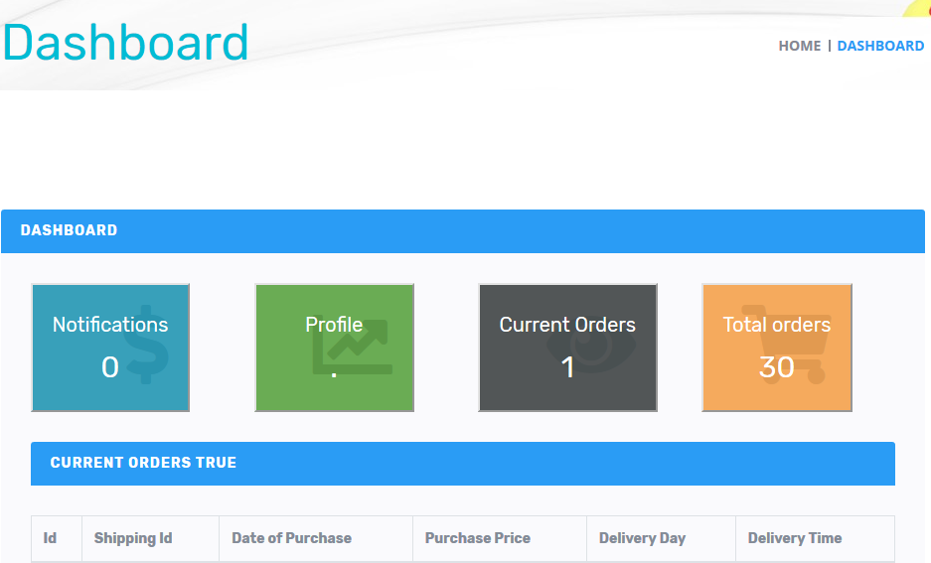

Users of the website have basic components that they can do such as view their orders and manage their profile (change profile picture, address, etc.)

**Separated header component**

**User Header**

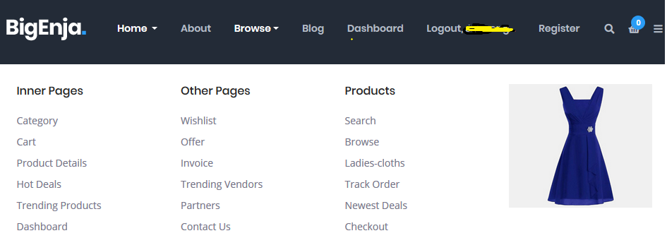

**Admin Header**

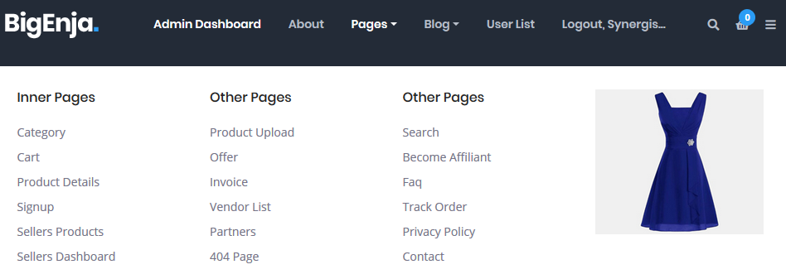

Depending on the role of the logged in user, their view will differ. Users should not be able to view certain pages.

**Administration Table**

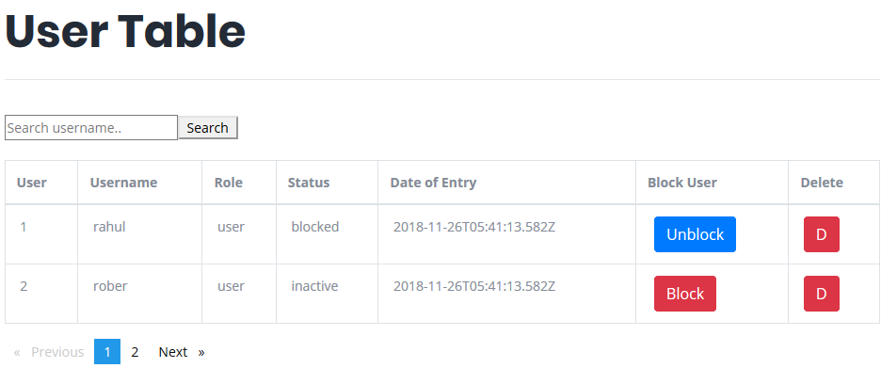

The user table that is only available to an admin of the website has the power to block and unblock users as well as deleting users at will. This control is one method of controlling unwanted users and vendors from the website.